**CrypToolStoreDatabase – “general ideas” - whitepaper**

Nils Kopal, 2018-07-24

The **CrypToolStoreDatabase** is the “ground truth” of the CrypToolStore. It stores “everything”:

* User data
* CrypToolStorePlugins source code
* CrypToolStorePlugin assemblies
* Resources (i.e. huge language statistics)

Description of “the world”:

* We have different **users** (developers).
* A user can upload and manage different **plugins**.
* A user can upload and manage different **resources**.
* A **plugin** has different versions of **source code**.
* A **resource** has different versions of **resource data**.
* Each **source** generates a single assembly.

Tables we need:

* **Users**
* **Plugins**
* **Source**
* **Resources**
* **ResourceData**

Here, are the relations between the tables.

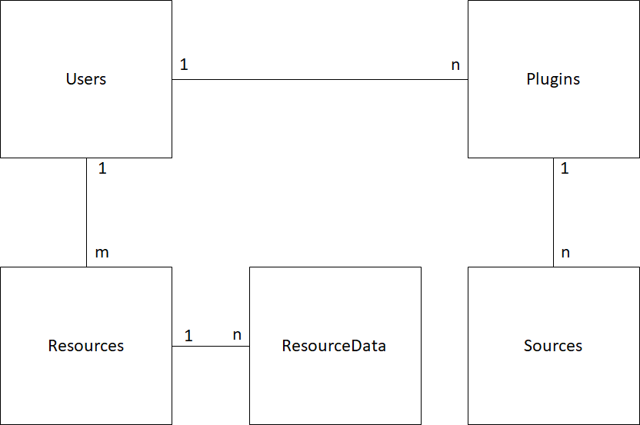

**Users** table:

|  |  |  |
| --- | --- | --- |
| Username | Varchar (50) | Unique, primary key |
| Firstname | Varchar (50) |  |
| Lastname | Varchar (50) |  |
| Password | Varchar (50) |  |
| Email | Varchar (150) |  |

**Plugins** table:

|  |  |  |
| --- | --- | --- |
| PluginName | Varchar (100) | Unique, Primary Key |
| PluginShortDescription | Varchar (100) |  |
| PluginLongDescription | Varchar (500) |  |
| AuthorNames | Varchar (500) |  |
| AuthorEmails | Varchar (500) |  |
| AuthorInstitutes | Varchar (500) |  |
| PluginIcon | Blob (image data) |  |
| ActiveVersion | Integer | Foreign Key |
| Publish | Varchar (1) |  |

**Sources** table:

|  |  |  |
| --- | --- | --- |
| PluginName | Varchar (100) | Primary Key, Foreign Key |
| PluginVersion | Integer | Primary Key |
| BuildVersion | Integer |  |
| Zipfile | Blob |  |
| BuildState | Varchar (100) |  |
| BuildErrorMessages | Varchar (1000) |  |
| BuildAssembly | Blob |  |
| BuildDate | DateTime |  |

**Resources** table:

|  |  |  |
| --- | --- | --- |
| ResourceName | Varchar (100) | Primary Key |
| ResourceDescription | Varchar (100) |  |
| ActiveVersion | Integer |  |
| Publish | Varchar (1) |  |

**ResourcesData** table:

|  |  |  |
| --- | --- | --- |
| ResourceName | Varchar (100) | Primary Key |
| ResourceVersion | Integer | Primary Key |
| ResourceData | Blob |  |
| UploadData | DateTime |  |